James P. Dildine
CI – 499 Fall 2004
September 30, 2004

Tetrahedral Volume Problem

Imagining the following as a cross section of a pyramid made of several other tetrahedral pyramids we have an empty center that we’d like to find the volume of.

The 2-D figure looks misleading so it would behoove us to create a (bad) 3-D model, shown below:
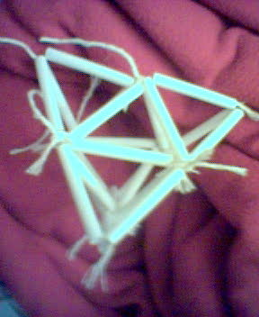
First, we notice that the interior “missing” volume looks like an Octahedron.
Second, we decide that to find this volume we can take the volume of the entire pyramid and subtract the volumes of the four regular tetrahedral solids, or we could find the volume of an octahedron.
Hmmm…
It seems much easier to find the volumes of the 4 tetrahedral pyramids and just subtract the sum of those volumes from the volume of the larger tetrahedron.

First taking ONE tetrahedron and finding it’s volume (at first glance) is relatively simple with the following formula:
Volume = 1/3 * area of the base * height of the pyramid
But finding these values requires a little manipulation
Let’s assume each tetrahedron has a base of 12 cm, a height of 8 cm.

