According to the NCTM (2000) “Instructional programs from pre-kindergarten through grade 12 should enable all students to:
- Analyze characteristics and properties of two and three dimensional geometric shapes and develop mathematical arguments about geometric relationships;
- Specify locations and describe spatial relationships using coordinate geometry and other representational systems;
- Apply transformations and use symmetry to analyze mathematical situations;
- Use visualization, spatial reasoning, and geometric modeling to solve problems.”

I chose the 1st item to pursue through the Pre-K – 16 curriculum. I spent some time looking at Glencoe’s series of textbooks which are used in the Urbana School system. I also looked at the Illinois learning standards (ILS) and benchmarks.
Most notable of the Illinois Learning Standards (ISBE, 1997) are included here:
Pages 24 – 26 of the ILS describe the following goal and standards:
Goal 9: Use geometric methods to analyze, categorize, and draw conclusions about points, lines, planes, and spaces.
This is a fairly vague statement that is clarified by the Learning Standard (B):
Identify, describe, classify, and compare relationships using points, lines, planes, and solids.
They then establish benchmarks across the grade levels which I will not repeat here.

I will explore a concept through the 1st recommendation from NCTM: The curriculum should enable all students to analyze characteristics and properties of two and three dimensional geometric shapes and develop mathematical arguments about geometric relationships. Following this concept through the curriculum from Pre-K to Grade 16 deals largely with building on ideas learned from each grade level. Finally we deconstruct and refit these concepts at the college level, while building a new knowledge set of Non-Euclidean figures and shapes.

This process can be summarized by the following example of curricular topic areas typically pursued:

Students are first introduced to figures and shapes, say a Triangle in the early grades. Students learn about and name this triangle, and identify what figures are triangles and which are not. Next students should learn some features about specific triangles, right, equilateral, area, and perimeter, among other features. Students should use triangles to solve problems with similarity, and congruence. Students should then build upon this knowledge and apply it to volume and surface area of triangular prisms, tetrahedral, triangular pyramids, etc...

One of the most important things that I have noticed is the use of more manipulatives and technologies, yet there is still not major adoption of these tools across curricula.

Pre-kindergarten – Grades 2/3
This period of time is an immense time for students to explore and become familiar with shapes and figures through the use of blocks, patterns and cut-outs of shapes. In the Pre – K and the early elementary school years (up to around grade 2 or 3) students are encouraged and expected to manipulate, draw, identify, and describe two dimensional shapes. They are encouraged to build two and three dimensional figures and shapes as well as use other figures or shapes to build more complex structures. They should be able to describe two dimensional figures or shapes and discriminate between them. Example: Triangles vs. Rectangles.

Students should begin hearing and using the terminology for these two and three dimensional figures and shapes. Students should begin using terms like cube, pyramid, cone, and cylinder. They should use these terms appropriately in the correct context.

Elementary School – Grades 3-5
Students should continue classifying figures and determining their characteristics. At this level students should have a level of comfort with working with the two-dimensional figures and should now be working to determine features about them; area, perimeter, acute vs. obtuse triangles, trapezoids, the entire quadrilateral family. From here they should be moving and typically are moving toward solids and describing their features. I recently visited a local elementary school and saw that students are exploring volumes of simple cubes and cones and cylinders. Curricular trends with figures and shapes have seen more and more explorations in reflections of figures, translations, tessellations, and rotations, especially at this level. This should and can be used more and more with dynamic software and manipulatives like the Mira.

Middle School – Grades 6-8
By the middle school level (Grades 6-8) students are generally using geometric figures and relationships to solve problems. Similar triangles are often used to determine the heights of buildings as in the example below (when the height of the tree is known and the angle of the viewer’s eye): A version of this is used at the 6th grade in a local school.

Students are moving from a strictly 2-D world and enhancing their knowledge of 3-D figures (solids) and should be using terms like Regular Polyhedra and describing what properties those figures have. At the same time Pre-algebra and Algebra students should and typically are combining their knowledge of Geometry with their Algebraic learning. A common example I really like is the Difference of Two Squares. I believe that this activity offers a wonderful bridge between what is often thought of as two distinct areas of mathematics. I’ve taught this in the classroom as well to Geometry students, Algebra students, as well as teachers and I believe all really learned something about this relationship. I would like to see this used more and actually included in the school’s curriculum. I am currently revising my lesson so that schools in the area can use it with physical as well as virtual manipulatives.

High School – Grades 9-12
As students enter high school the geometry curriculum typically involves the realms of proof and even coordinate geometry. Each of these areas can and do expand on the students knowledge as for the former the students must present concrete arguments utilizing theorems and axioms explored. Students are not allowed to take at face value that the triangles above are similar and everything works out in proportions. They must show that by using Angle-Angle they can prove two triangles are similar.

The Pythagorean Theorem is introduced in the middle school years but students should now become very familiar with this relationship especially as shown in the following sketches. I have not seen this explored in current curricula but I believe it will help students learn about how the sides of a right triangle are related in a variety of ways through the Pythagorean Theorem.
The squares of the sides: | Equilateral Triangles on each of the sides:
Semi-circles on each of the sides:  Related to Blackwell’s Theorem | Pentagons on each of the sides:
The first sketch is your typical demonstration of the Pythagorean relationship of the squares built on each side of the right triangle. The largest square area is the sum of the two smaller square areas. Students can explore how other figures can be placed on the sides of a right triangle and the areas of these figures are related in the exact same way.
Students should also pay particular attention to the relationships among the quadrilaterals, their diagonals, and their midpoints.

I’ve noticed in some schools, coordinate Geometry is not given as much attention as I remember. Students should become familiar with the distance formula and reading from a coordinate grid at this time in their careers. One might argue too that Polar graphing receives more attention as well.

Post Secondary Grade 13-16
Note that neither NCTM nor The Illinois Learning Standards address curricula beyond grade 12. By grade levels 13-16 students should begin experimenting with different forms of Geometry to help them visualize how figures are related in different geometric worlds. Examples include Non-Euclidean Geometric systems, projective geometry, and analytic geometry as evident in the Calculus.

Here is what an equilateral triangle looks like in Hyperbolic Geometry.
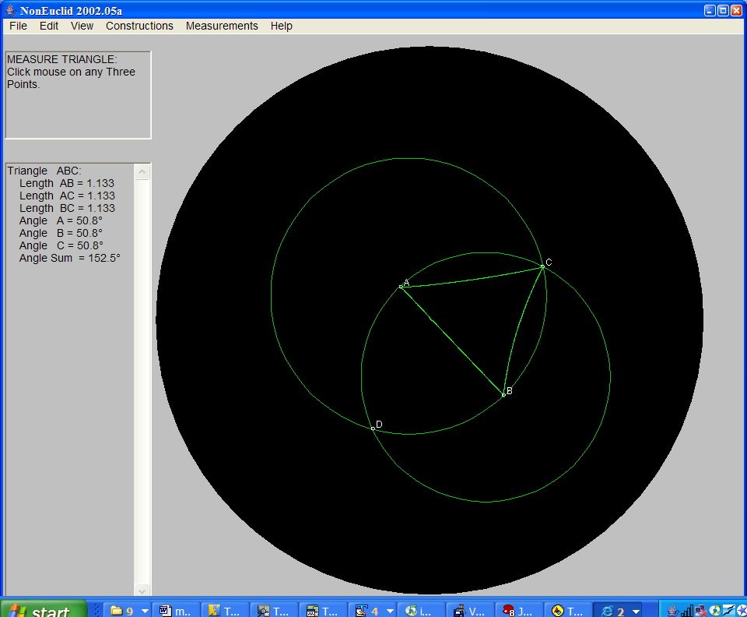

And the same triangle after manipulating a point of one of the circles.
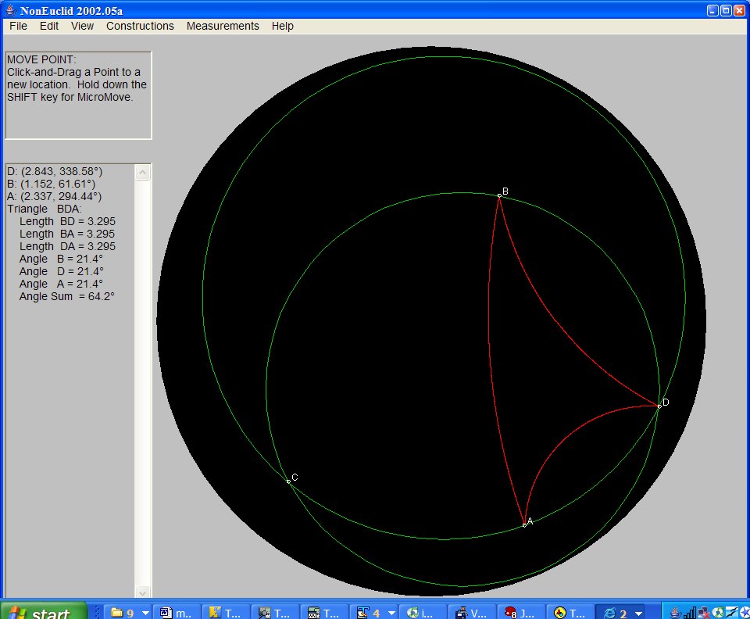

Non-Euclidean Geometry is common in the curriculum geared toward Mathematics majors, Mathematics Education majors, and often Engineering students. I would recommend that all college students take a course in Non-Euclidean Geometry. I believe this would help them understand the world that we live in, as it is not Euclidean, but rather spherical in nature. Hyperbolic Geometry helps students to also understand concepts of space.

I specifically recall one of my most enjoyable experiences in what was Math 302 at the U of I. This course dealt with examining Euclid’s postulates in the context of Non-Euclidean Geometry. Notably, do parallel lines exist in the same way that they do on a Euclidean plane? Do right triangles exist? How about squares? This type of Geometric study turns the Geometry the students have been studying since Pre-kindergarten on “its head”. However, given that the students have arrived at this point in their mathematics studies they should be able to use their knowledge of Euclidean Geometry to develop mathematical arguments about geometric relationships in a Non-Euclidean world.

Up to this point students have been using figures to help them solve problems while exploring the properties of these figures. All of a sudden in a Hyperbolic world, rectangles (hence squares) do not exist and the sum of the interior angles of a triangle is less than 180 degrees. This is contradictory to everything we’ve learned about these figures up to this point. Note that a circle is still a circle.

Another aspect of a Non-Euclidean Geometry system is frequently mentioned in most middle and high school curricula however it is rarely explored beyond the aspect of pretty pictures or artistic uses. This is projective or perspective geometry as shown here:

Again, this type of Geometry contradicts what students have been studying for years. This is a rectangular box as viewed in a perspective plane.

The inclusion of a Geometry course for all or most college-level students is a worthwhile endeavor. All too often the Calculus sequence is seen as the capstone of a student’s mathematics education. While Calculus is indeed a worthwhile endeavor especially for those students pursuing the sciences, Geometric ideas like those shown above instead of a basics retread, which is evident in many community-college textbooks, might be a more exciting and interesting path to pursue. Notably, the topics explored in a Non-Euclidean course might be of benefit to those pursuing art, science, or aviation, among other areas. The ideas explored in these courses take what the student has experienced their entire lives as “true” and allows them to rethink these truisms in a whole new world.

Conclusion
The curricula and standards I examined and my reflections on my experiences teaching and taking courses have made me consider different approaches to exploring the Geometric concepts typically presented with figures and shapes and solids. These concepts move through the Geometry curriculum in a variety of manners, and encourage the student to explore them in a many different contexts and within several different depths. Having the opportunity to work in different school settings (elementary, middle school, high school, and college-level) has allowed me to see the diverse methods that are utilized to teach these concepts across the grade levels. The possibilities for teaching and learning Non-Euclidean Geometry while only exploring these simple geometric figures is fascinating to me and I encourage more teachers to engage in that discovery. I am still amazed when I attempt constructions in Spherical and Hyperbolic Geometries and I am certain many younger students would as well. Perspective Geometry also has the capacity to entice students to learn more about the properties of shapes and how they can be distorted to create wonderful artwork.

Note: Curriculum can be separated into at least three separate domains, I tried to envision and write this paper within those three domains.
- The Intended (What do teachers intend their students to learn?),
- The Implemented (What do teachers actually teach?), and
- The Attained (What have students learned from the culmination of the above?)

After teaching for several years that became even more obvious. Rarely do school districts or administrators look at the disjoint between the 1st tier and the 3rd tier. Typically they look at the 2nd tier and 3rd tier. It boils down to basic economics (What did we get for our money?). There is rarely a plan in place, at least long enough, to relate the 1st tier and 3rd tier. Nor is there foresight to keep it going among mounting congressional and senate bills.

References:
- Hauptman, H., Posamentier, A. (2001). 101 Great Ideas for Introducing Key Concepts in Mathematics. Thousand Oaks, CA: Corwin Press, Inc.
- Key Curriculum Press (2004). The Geometer’s Sketchpad. V. 4.06. Emeryville, CA: Key Curriculum Press.
- National Council of Teachers of Mathematics (NCTM). (1997). Curriculum and Evaluation Standards for School Mathematics: Addenda Series Grades 5 - 8, Geometry in the Middle Grades. Reston, VA: The National Council of Teachers of Mathematics, Inc.

- NonEuclid, Located at cs.unm.edu/~joel/NonEuclid/

- National Council of Teachers of Mathematics (NCTM). (2000). Pinciples and Standards for School
- Mathematics. Reston, VA: The National Council of Teachers of Mathematics, Inc.

- Tondeur, P. (1993). Vectors and Transformations in Plane Geometry. Houston: Publish or Persish, Inc.

- Wallace, E., West, S. (1992). Roads to Geometry. Englewood Cliffs, NJ: Prentice Hall.

