Using your ED-Doh, not to be confused with Play-Doh TM, create your own pseudo-FlatLand then using Relational Geosolids jam a solid into your FlatLand. Notice the figure it makes in your FlatLand. Since our FlatLand exists on a table we can’t really pass through it all the way. But we think you’ll get the idea.
Try to make the following figures with various solids & describe the solids chosen (the name of the solid would be great but a general description is also wonderful) and how you created the figure:

Square:_______________________________________________________________________________

Triangle:______________________________________________________________________________

Equilateral Triangle:____________________________________________________________________

Rectangle:_____________________________________________________________________________

Circle:________________________________________________________________________________

Please, answer the following questions:
What types of solids passing through your FlatLand would appear as women?

What types of solids passing through your FlatLand would appear as priests?

What types of solids passing through your FlatLand would appear as tradesmen?

What types of solids passing through your FlatLand would appear as pentagons, hexagons, octagons?

Considering a set of regular polyhedra or the Platonic Solids as they are known what figures could/would they appear as passing through FlatLand? List as many as you can.
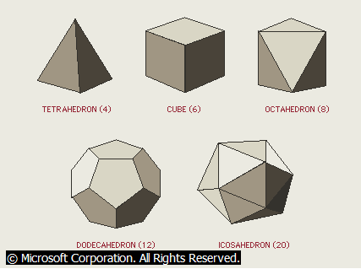

Tetrahedron:__________________________________________________________________________

Cube:_________________________________________________________________________________

Octahedron: ___________________________________________________________________________

Dodecahedron:_________________________________________________________________________

Icosahedron:___________________________________________________________________________

Now, (for fun), take any random object (pen?) or body-part (the nose?) and try to make impressions in the ED-Doh that may look like a resident of FlatLand (any resident you’d like). Draw & describe your resident below:

In the event that you’d like to try this in your classroom or even at home, here are the directions for making ED-Doh graciously provided by Marla Smith and the entire Early Child Education and Care (ECEC) team & students at Technology Center of DuPage (TCD).
*Special Thanx and Props to ALL of these people*

OK HERE IT GOES:
For a standard batch you need:
2 cups of flour
1 cup of salt
2 cups of water
¼ cup vegetable oil
¼ cup of cream of tartar
If you want color you should add a couple drops of food coloring as well

Then, mix all these ingredients together (very well) and heat them over medium heat. Until they thicken and then knead the compound until it is of desired consistency (i.e. doughy). Enjoy! But Don’t Eat!

