C & I 499
Assignment October 28, 2004
James P. Dildine

Using only the Triangles included in our GeoFix Kit build the following with the fewest number of triangles to make the polyhedron rigid. Photos are included.

- A Tetrahedron with edge length of one unit: 4 Triangles are used to make it with 3 it is still rigid.
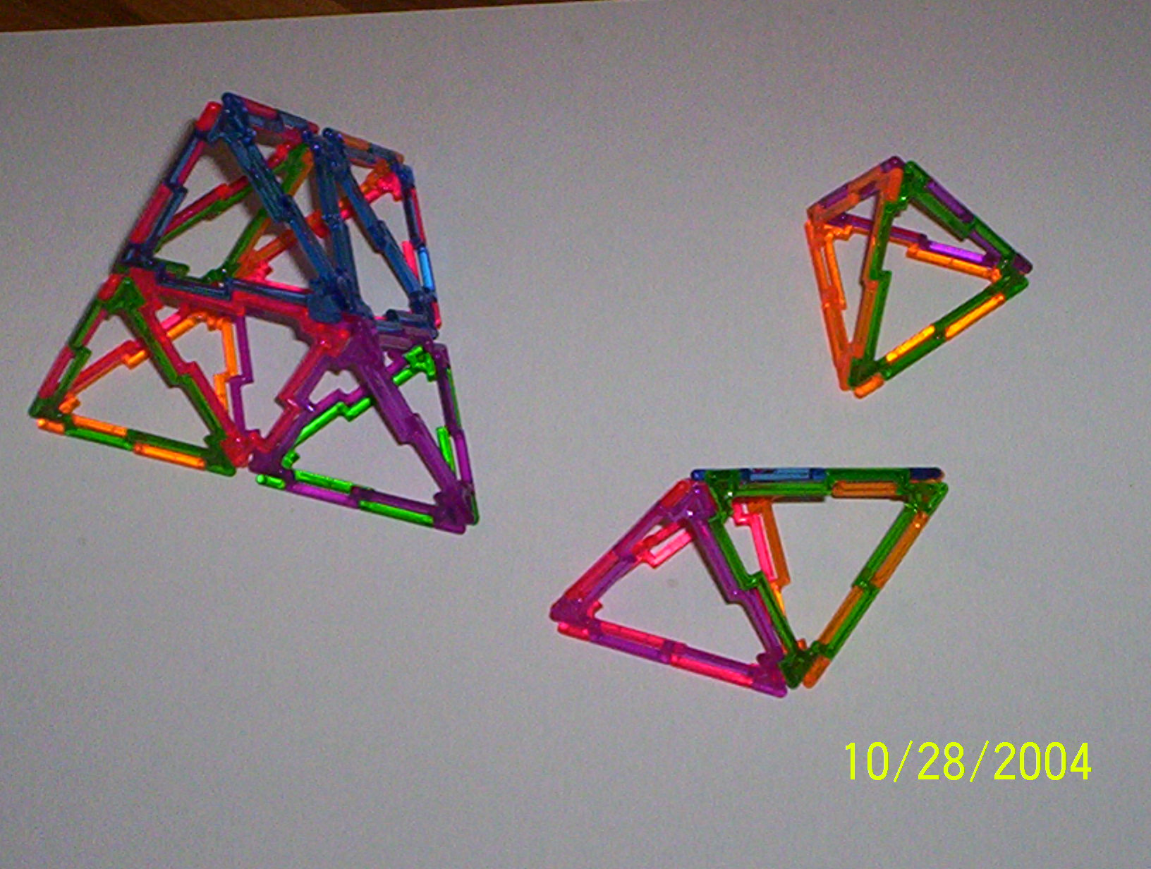
- A Tetrahedron with edge length of two units: 16 Triangles are used to make it with 13 it is still rigid.
- An Octahedron with edge length of one unit: 8 Triangles are used to make it with 6 it is still rigid.
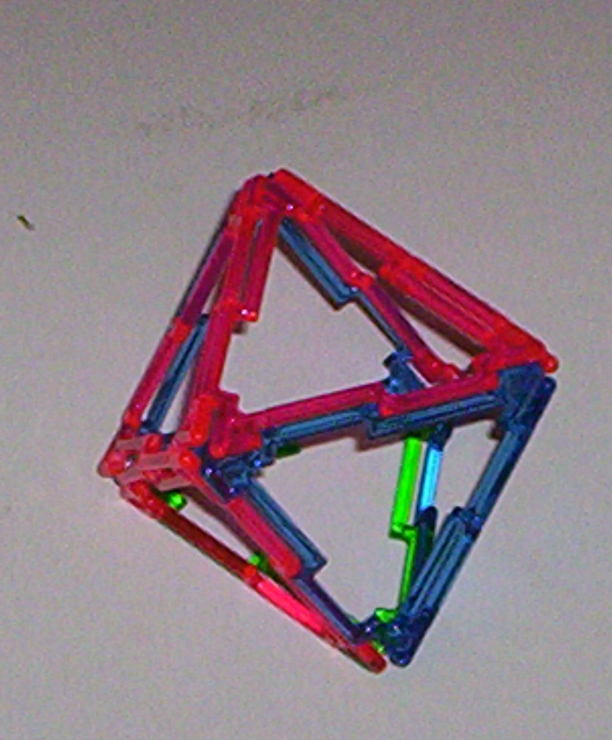
- An Octahedron with edge length of two units: 32 Triangles are used to make it with 26 it is still rigid.
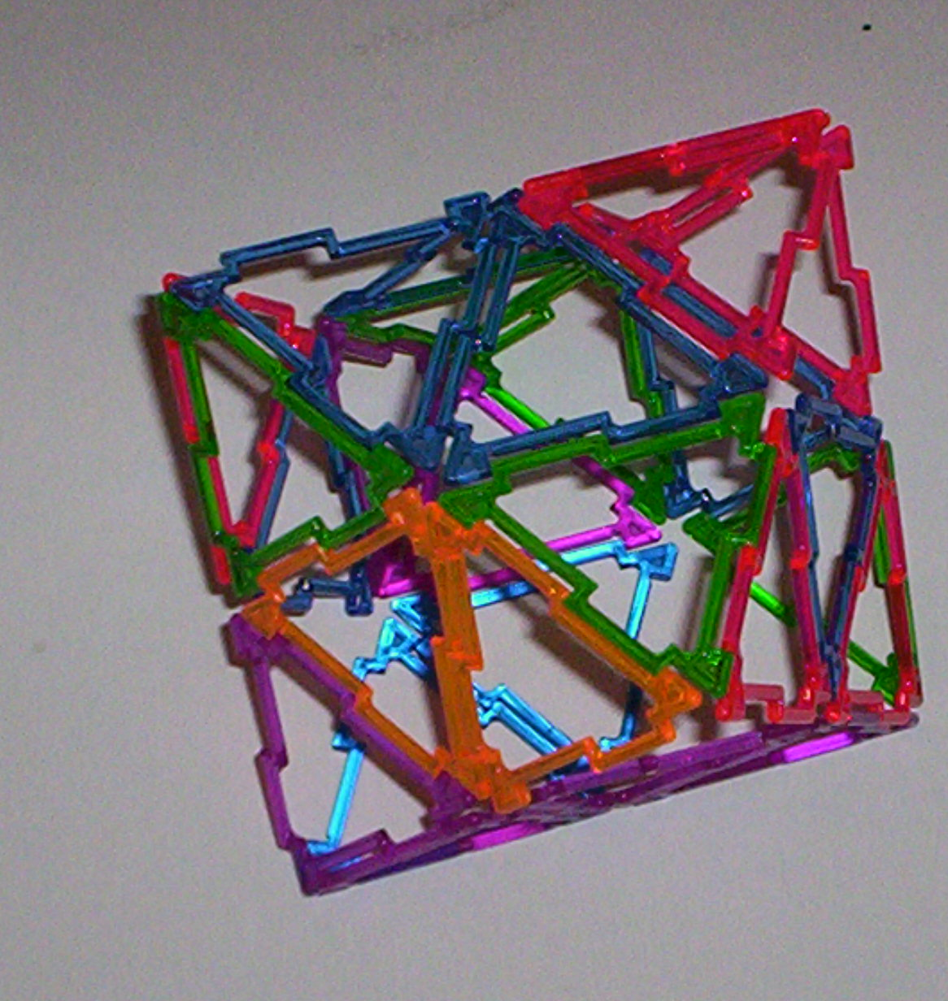

I created additional interesting figures, as well. A stellated decahedron with several tetrahedra. And the same figure turned inside out. Each figure with 10 pentagons and 30 Triangles.
