THE GEOMETRY OF PERSPECTIVE AND PROJECTIVE GEOMETRY

NCTM makes it clear that in grades 6-12 students should “Use visualization, spatial reasoning, and geometric modeling to solve problems.” (NCTM, p. 397) NCTM describes additional expectations in these grades through the following:
All students should –
“Recognize and apply geometric ideas and relationships in areas outside the mathematics classroom, such as art, science, and everyday life.”
“Use geometric ideas to solve problems in, and gain insights into, other disciplines and other areas of interest such as art and architecture.”

Euclidean Geometry presents a myriad of postulates and axioms. Sometimes these axioms and postulates do not hold true in our “real world”.

It is within the guidelines suggested by these standards that I embarked on a project about perspective & projective geometry. I’ve also been very interested in the manner in which I could demonstrate these ideas using technology.

I was first drawn to this topic about nine years ago while taking Math 302 taught by George Francis at the University of Illinois. In that class we explored the text: Roads to Geometry by Edward Wallace and Stephen West (1992). Toward the end of the class we briefly looked at Perspective/Projective Geometry. I was fascinated as I had not known how extensive the mathematical study of this topic was. I eventually graduated and proceeded to teach at a vocational high school and worked closely with the Pre-architecture/Pre-engineering instructor – Luciano Sestito. While working with him and AutoCAD software I again became interested in Perspective Geometry. I worked with students and helped them develop perspective drawings in the CAD software.

The students and I discussed how these drawings looked versus how they fit within the “real world”. We discussed parallel lines, perpendicular lines, and ways to make 3-D objects look real in a 2-D computer screen. This is when I realized that most students do not encounter non-Euclidean geometry in particular perspective geometry in the typical mathematics curriculum. I then realized that I personally had not encountered it either until my later undergraduate years. In the spring of 2004 I attended Math 303, again with George Francis as instructor, to further explore Non-Euclidean Geometry. This class reintroduced me to perspective/projective geometry with Desargues Theorem, Pappus’ Theorem, and Ceva’s Theorem, among other ideas. I will present the ways in which I explored Desargues’ Theorem and how it relates to projective/perspective geometry.

DESARGUES’ THEOREM AND PROJECTIVE GEOMETRY

A French Mathematician (1593-1660), Desargues is often considered the inventor of projective geometry. He is credited with relating point perspectivity and line perspectivity in his famous theorem.

Desargues Theorem states the following:
Two (non-coplanar) projective triangles are perspective with respect to a point if and only if they are perspective with respect to a line. (Wallace & West p. 360)

Illustrating this Theorem using GSP we see that triangles ABC and A’B’C’ are in perspective to point P. They are also in perspective to line XYZ.

Follow these directions to create a Desargues’ Theorem Model. It Can be done on paper or GSP, or in your driveway (shown later).
- Draw three intersecting lines and label the intersection point P.
- Inscribe two triangles on these lines and label them ABC, and A’B’C’.
As Shown:
3. Extend Corresponding sides (AB, A’B’) Construct their intersection point (label it X). Repeat for Sides BC & B’C’ labeling the intersection Y, and finally AC & A’C’, labeling this last intersection Z. Now, draw a line through the three points.
It should look similar to the following picture.

This is an illustration of Desargues’ Theorem. Restated, we can see the following relationships. Two (non-coplanar) projective triangles are perspective with respect to a point if and only if they are perspective with respect to a line. (Wallace & West p. 360) The two triangles are in perspective through point P. As the smaller triangle is projected onto ABC, looking through point P. In addition, the triangles are in perspective on their planes according to line the XYZ.

This figure a nice example to view in Geometer’s Sketchpad as it offers the student the opportunity to examine how the relationships are retained as the figure is moved about the sketch.

Try out a decent Java-sketch located online at www.mste.uiuc.edu/dildine/classes/ci499fall04/desargues.html

I soon realized that drawing this on paper or on GSP provided a great way to see the theorem but I still did not really understand it. I also realized that if I was going to present on this topic and be able to talk about it clearly and coherently I needed to truly understand it. I began researching the topic through various mathematics books (not text books). I discovered in The Art of the Infinite: The Pleasures of Mathematics by Ellen and Robert Kaplan a drawing that looked like this (theirs was much more elegant but the idea should be clear).

I began to think of the two planes as flaps of a file folder and the intersections of lines drawn from AC & A’C’, BC & B’C’, and AB & A’B’ could be collinear along the fold line and then I took some twine to connect B’B, C’C, and A’A with them meeting at point P. I was amazed when after several tries it actually worked. I tried it out on a few other people and it still worked for them too. This was amazing to me as I had a new idea of what was going on in this theorem. I choose to share this with the group using the following directions:

- Take a piece of twine and cut three equal lengths (about a foot each). Take a file folder and draw a triangle near the center of the inside of the file folder. Now this is tricky because we want to rig our file folder so that the sides will all extend to the folder’s fold line. Label these vertices (A,B,C) Fold the file folder and draw another triangle on the opposite folder flap (on the outside) that appears inside the larger, triangle. Again try and rig your triangle so the sides extend to the fold. Label these vertices (A’, B’, C’) Poke holes into the outside triangle and thread your twine through. Tape the twine pieces to the vertices of the larger triangle.
- Now, with a partner, one person should hold the pieces of twine together outside of the file folder while the other person opens the file folder and looks into it to see the following. The twine should be taut without too much bending.
Two views of how it should look are shown below: P is the point where the person outside the folder should be holding the twine. Note the bottom panel of the file folder should remain flat on your table surface. It might help to tape it down.
Two side views:
- Triangle ABC is considered the projection of triangle A’B’C’. If you are lucky you will also notice the following relationship. Draw a connecting line outward from CA to the fold line of the folder, do the same with BA, and BC. Repeat the procedure with A’C’, A’B’, & B’C’. If all goes well you should see something representing the following figures or close to it. It’s hard to keep everything on the file folder but the next activity might help you see the relationship.

Flat view (no strings):

Frontal view (strings are dashed lines extending to point P):

I also wanted the students to draw the theorem on paper or demonstrate it on GSP, or even both. When thinking about the paper drawing and how frustrating it can be to keep the collinear points on the sheet of paper I tried this construction out in my driveway on a slightly larger surface (as shown). I was also hoping to use this as “ammo” for anyone who says that their students would get frustrated after running out of room on the paper.
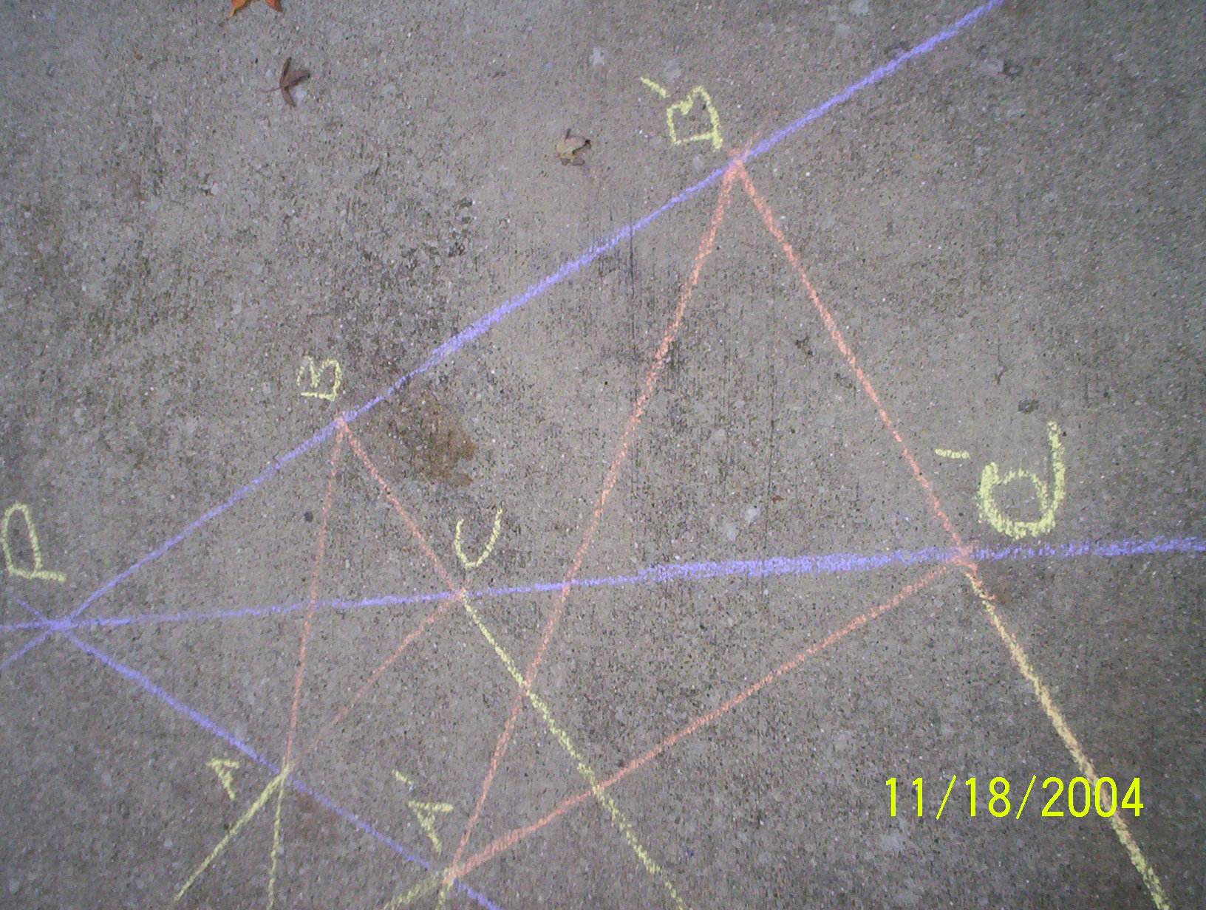

However, I still ran out of room for the last point as circled.
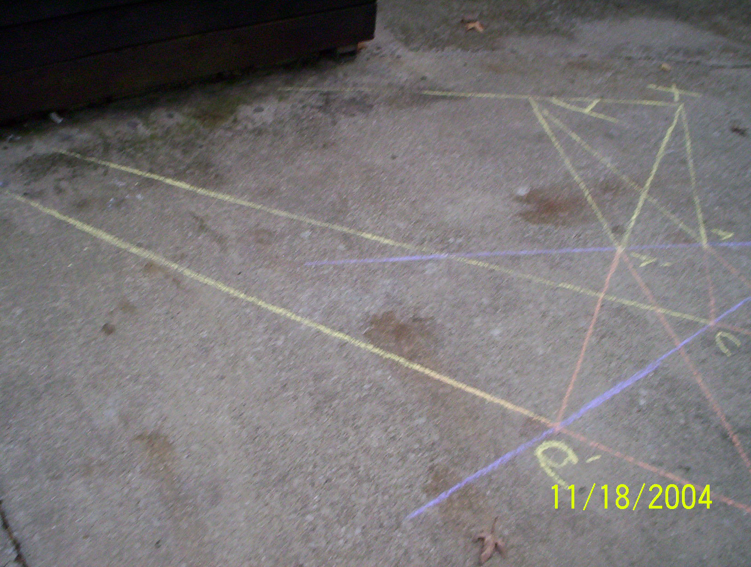

I was not very pleased but the idea was evident to me that it could be done with chalk and a big ruler. It would be interesting to see in a school parking lot.

Finally I realized that I probably should start with a motivating activity. I chose to cut out triangles and have students investigate that through a flashlight you can produce a projection of these triangles using a flashlight. These projections take on a variety of formations and sizes.

As an extension we can explore perspective geometry through the traditional presentation of one and two point perspective as described in the next section and in my interactive GSP file at:
www.mste.uiuc.edu/dildine/classes/ci499fall04/mainproject.gsp
It is full of useful links and resources and description of creating each sketch.
OTHER ASPECTS/TOPICS OF PERSPECTIVE/PROJECTIVE GEOMETRY

Deargues paved the way for other geometers to pursue projective/perspective geometry.
These examples illustrate those manners in which Desargues provided the foundation for One & Two Point-perspective Geometries.

One-point perspective – all the parallel lines of an object recede and converge at a single “vanishing point”.
Using GSP we can draw a box in one-point perspective:

Two-point perspective –
Using GSP we can draw another box, this time in two point perspective:
CURRICULAR RECOMMENDATIONS ABOUT
PERSPECTIVE/PROJECTIVE GEOMETRY
Exploring the ideas of projective/perspective geometry can be implemented in the curriculum as early as the pre-elementary grades and be expanded throughout the geometry strand of the students’ learning all the way to post secondary levels. These topics are designed to lead the students to a more thorough understanding of projective geometry. Historical and additional cross-curricular topics will be identified as well. NCTM’s recommendations that I used as a basis are listed in the Appendix.
Pre-Elementary and Elementary
Here are some curricular ideas meant to foster exploration of projective geometry in the pre-elementary and elementary grades (Note: these are suggested activities and curricular topic ideas, they are by no means exhaustive):
Students are encouraged to recognize and classify shapes. Students can also play with ideas of projecting these shapes onto the wall or the floor using flashlights or the sun.
Questions that can be addressed:
- What happens when a light is shined on these shapes and they are projected onto a wall?
- How do people’s shadows look when they stand in the sun?
- Are these shadows longer, the same, or shorter?
- What different kinds of shapes can be made by projecting certain shapes?
Students should be encouraged as in the elementary examples to manipulate the shapes’ position, distance from the light source, from the wall, as well as other configurations.
Students in later elementary grades and middle school may also benefit from projecting three-dimensional objects and noting their characteristics (This is especially useful after exploring regular polyhedra):
For example students can complete the following table (again not exhaustive):

Project the following 3-D objects using a flashlight and complete the table
Object | How many different figures result from projection? | What types of figures are they? | What are some limitations of using this figure?
Sphere (Ball) | 1 | Circles | Can only project a circle.
A Hockey Puck
Tetrahedron
Cube
Rectangular Prism
Assorted other figures
In completing the table students should be encouraged as in the elementary examples to manipulate the figures’ position, distance from the light source, from the wall, as well as other configurations.
Middle School Grades and Early High School
Students in these grades would benefit from exploring and creating drawings in one and two point perspectives.
First, they should be able to describe the following:
- Vanishing point
- Horizon
Second they should recognize the difference between the appearance of the following in 2-D and 2-D perspective
- Perpendicular line
- Parallel line
Students should also recognize that perspective drawing is widely used in art especially that of:
- Durer
- Alberti
- DaVinci
They should be encouraged to recognize the type of perspective drawing used in several pieces of art, create their own artwork in perspective, and/or take photos in perspective or find photos and identify the perspectivity.
Late High School through College
Here is where Desargues’ Theorem can be explored.
Students should be expected to complete the directions for creating Desargues’ Theorem on paper and/or GSP.
Once students understand how to do this they can enter the phase I was in until a few months ago…The “So what” phase. At this point we can have the students create the three-dimensional model of the theorem and explore its relationship to the one and two point perspectives models.
After this understanding is achieved through empirical means it might be useful to explore the proof of why this works. This is likely to be encountered in a higher level undergraduate mathematics class. This is accomplished by using Pappus’ Theorem and Ceva’s Theorem which will be useful to have had experience with.
These are the additions to the current geometry curriculum I would offer in order to incorporate more perspective geometry. My classmates offered some wonderful advice and feedback about the physical model activity and how they were able to see the paper construction much better while using GSP.

REFERENCES
- Austin, D. & Dickinson, W. (2004). Spherical Easel. http://merganser.math.gvsu.edu/easel/
- Dildine, J. (2004). Mainproject.gsp www.mste.uiuc.edu/dildine/classes/ci499fall04/mainproject.gsp
- Hauptman, H., Posamentier, A. (2001). 101 Great Ideas for Introducing Key Concepts in Mathematics . Thousand Oaks , CA : Corwin Press, Inc.
- Kaplan, R. & Kaplan, E. (2003). The Art of the Infinite: The Pleasures of Mathematics . New York : Oxford University Press.
- Key Curriculum Press (2004). The Geometer's Sketchpad. V. 4.06. Emeryville , CA : Key Curriculum Press.
- Sanders Cathi (1994). Perspective Drawing with The Geometer's Sketchpad. Emeryville , CA : Key Curriculum Press.
- Mathworld (2004). http://mathworld.wolfram.com/topics/ProjectiveGeometry.html
Contains very useful content about a wide variety of projective geometry topics
- Miller, C (1997). Mathematical Ideas. Reading, Mass: Addison-Wesley.
- National Council of Teachers of Mathematics (NCTM). (1997). Curriculum and Evaluation Standards for School Mathematics: Addenda Series Grades 5 - 8, Geometry in the Middle Grades . Reston , VA : The National Council of Teachers of Mathematics, Inc.
- National Council of Teachers of Mathematics (NCTM). (2000). Pinciples and Standards for School Mathematics . Reston , VA : The National Council of Teachers of Mathematics, Inc.
- Castellanos, J. (2002) Non-Euclid Geometry Software. http://cs.unm.edu/~joel/NonEuclid/
- Sanders, C. (1994). Perspective Drawing with The Geometer’s Sketchpad. Emeryville, Ca: Key Curriculum Press.
- Serra, M. (1997). Discovering Geometry. Emeryville, Ca: Key Curriculum Press.
- Tondeur, P. (1993). Vectors and Transformations in Plane Geometry . Houston : Publish or Persish, Inc.
- Wallace, E., West, S. (1992). Roads to Geometry . Englewood Cliffs, NJ: Prentice Hall.

APPENDIX
This is the set of Geometry Standard recommendations from NCTM’s PSSM, with the recommendations that address my recommendations highlighted.
Geometry Standard
Instructional programs from prekindergarten through grade 12
should enable all students to—
Analyze characteristics and properties of two- and three-dimensional geometric shapes and develop mathematical arguments about geometric relationships
Pre-K–2 Expectations:
In prekindergarten through grade 2 all students should–
• recognize, name, build, draw, compare, and sort two- and three-dimensional shapes;
• describe attributes and parts of two- and three-dimensional shapes;
• investigate and predict the results of putting together and taking apart two- and three-dimensional shapes.

Grades 3–5 Expectations:
In grades 3–5 all students should–
• identify, compare, and analyze attributes of two- and three-dimensional shapes and develop vocabulary to describe the attributes;
• classify two- and three-dimensional shapes according to their properties and develop definitions of classes of shapes such as triangles and pyramids;
• investigate, describe, and reason about the results of subdividing, combining, and transforming shapes;
• explore congruence and similarity;
• make and test conjectures about geometric properties and relationships and develop logical arguments to justify conclusions.

Grades 6–8 Expectations:
In grades 6–8 all students should–
• precisely describe, classify, and understand relationships among types of two- and three-dimensional objects using their defining properties;
• understand relationships among the angles, side lengths, perimeters, areas, and volumes of similar objects;
• create and critique inductive and deductive arguments concerning geometric ideas and relationships, such as congruence, similarity, and the Pythagorean relationship.

Grades 9–12 Expectations:
In grades 9–12 all students should–
• analyze properties and determine attributes of two- and three-dimensional objects;
• explore relationships (including congruence and similarity) among classes of two- and three-dimensional geometric objects, make and test conjectures about them, and solve problems involving them;
• establish the validity of geometric conjectures using deduction, prove theorems, and critique arguments made by others;
• use trigonometric relationships to determine lengths and angle measures.

Use visualization, spatial reasoning, and geometric modeling to solve problems
Pre-K–2 Expectations:
In prekindergarten through grade 2 all students should–
• create mental images of geometric shapes using spatial memory and spatial visualization;
• recognize and represent shapes from different perspectives;
• relate ideas in geometry to ideas in number and measurement;
• recognize geometric shapes and structures in the environment and specify their location.

Grades 3–5 Expectations:
In grades 3–5 all students should–
• build and draw geometric objects;
• create and describe mental images of objects, patterns, and paths;
• identify and build a three-dimensional object from two-dimensional representations of that object;
• identify and draw a two-dimensional representation of a three-dimensional object;
• use geometric models to solve problems in other areas of mathematics, such as number and measurement;
• recognize geometric ideas and relationships and apply them to other disciplines and to problems that arise in the classroom or in everyday life.

Grades 6–8 Expectations:
In grades 6–8 all students should–
• draw geometric objects with specified properties, such as side lengths or angle measures;
• use two-dimensional representations of three-dimensional objects to visualize and solve problems such as those involving surface area and volume;
• use visual tools such as networks to represent and solve problems;
• use geometric models to represent and explain numerical and algebraic relationships;
• recognize and apply geometric ideas and relationships in areas outside the mathematics classroom, such as art, science, and everyday life.

Grades 9–12 Expectations:
In grades 9–12 all students should–
• draw and construct representations of two- and three-dimensional geometric objects using a variety of tools;
• visualize three-dimensional objects and spaces from different perspectives and analyze their cross sections;
• use vertex-edge graphs to model and solve problems;
• use geometric models to gain insights into, and answer questions in, other areas of mathematics;
• use geometric ideas to solve problems in, and gain insights into, other disciplines and other areas of interest such as art and architecture.
